Ex.No :3

**DML Commands – INSERT, SELECT**

**Aim:**

To perform Data Manipulation Language (DML) Commands such as INSERT, SELECT

1.Populate all the five tables with your own data.

mysql> insert into student values('191711342','LASYA','F','2005-11-15','1234567890','KOVURU');

mysql> insert into student values('192211068','JASWANTH','M','2004-12-14','1234567980','PUTTUR');

mysql> insert into student values('192211084','VENKAT','M','2004-10-04','1234567089','PUTTUR');

mysql> insert into student values('192211169','PRIYA','F','2005-11-15','1234765089','NELLORE');

mysql> insert into student values('192211123','MAHITH','M','2004-10-17','1274365089','TIRUPATI');

mysql> select* from student;

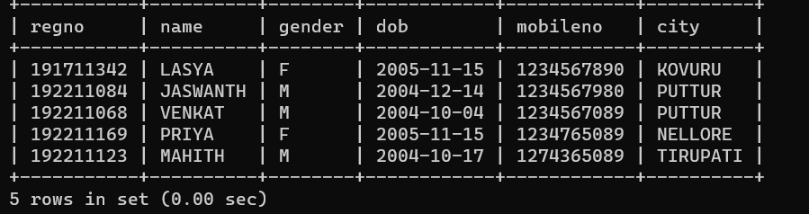

alter table faculty add column(Res char(4));

mysql> insert into faculty values('0010','geetha','F','1973-08-15','1998-01-01','1230987654','01','no');

Query OK, 1 row affected (0.01 sec)

mysql> insert into faculty values('0011','ram','M','1970-04-14','1999-05-10','1230987654','02','no');

Query OK, 1 row affected (0.01 sec)

mysql> insert into faculty values('0013','malini','F','1955-02-02','1998-11-17','1230987654','01','no');

Query OK, 1 row affected (0.01 sec)

mysql> insert into faculty values('0014','rajani','F','1990-05-02','2016-11-17','1230987654','03','yes');

Query OK, 1 row affected (0.01 sec)

mysql> insert into faculty values('0015','siva','M','1990-01-01','2015-09-08','1230987654','04','no');

Query OK, 1 row affected (0.01 sec)

mysql> select* from faculty;

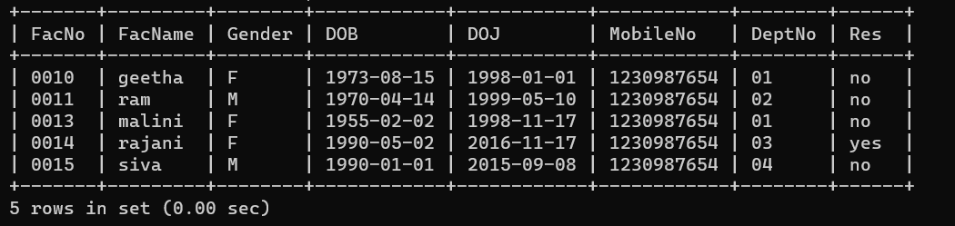

mysql> insert into department values('01','cse','vs');

mysql> insert into department values('02','civil','ms');

mysql> insert into department values('03','mechanical','ga');

mysql> insert into department values('04','ece','hr');

mysql> insert into department values('05','medical','kv');

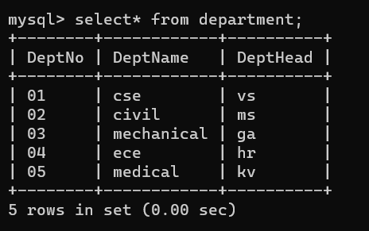

mysql> insert into course values('C01','dbms','M','2','502','3001');

mysql> insert into course values('C02','ethics','E','2','112','3002');

mysql> insert into course values('C03','AI','M','1','412','3003');

mysql> insert into course values('C04','english','M','4','421','3004');

mysql> insert into course values('C04','english','M','4','421','3004');

mysql> insert into course values('C05','C','M','3','321','3005');

mysql> insert into course values('C06','ds','M','2','NULL','3006');

mysql> insert into course values('C07','sql','E','3','NULL','3004');

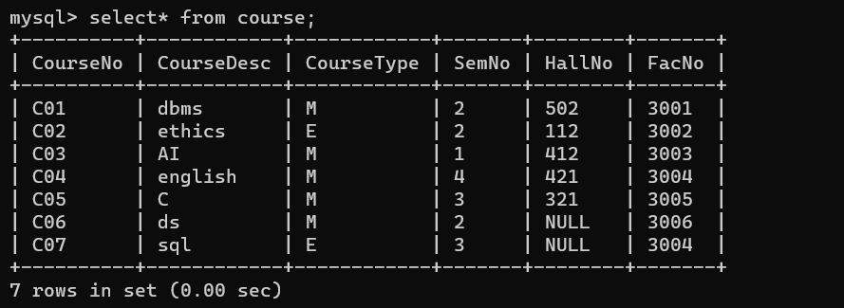

2.Modify the date of birth for the faculty whose name is 'RAM' with a value ‘1983-05-01’.

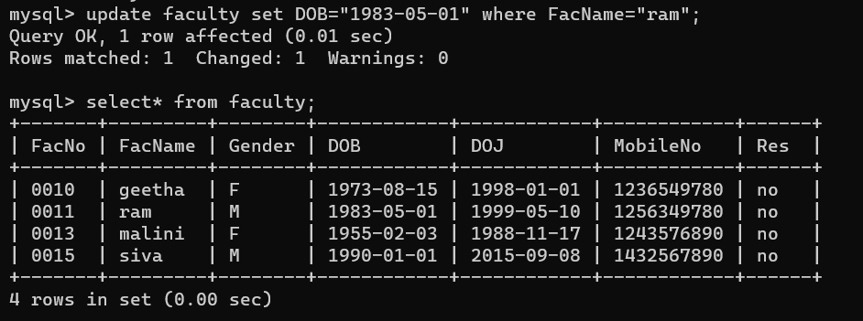

3.Remove all faculty who are having over 65 years.

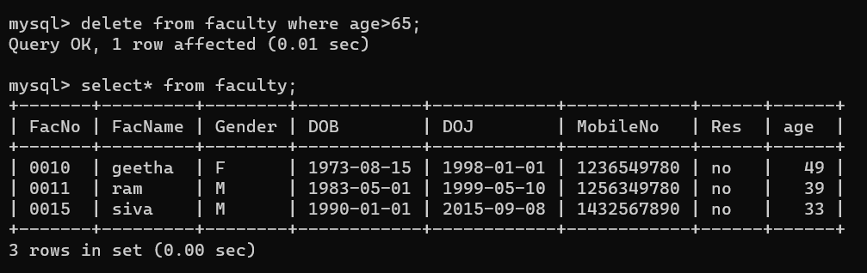

4.View all the records from the five tables. Exercise

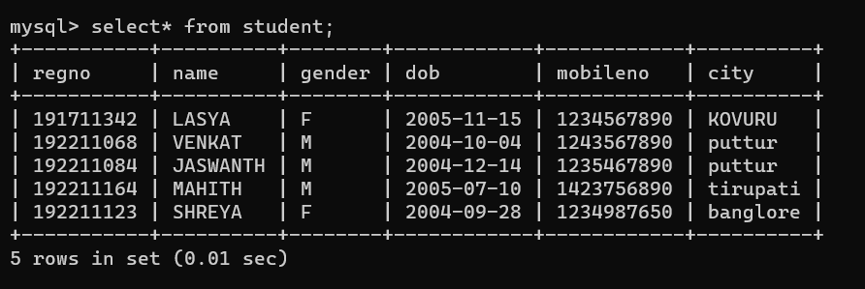

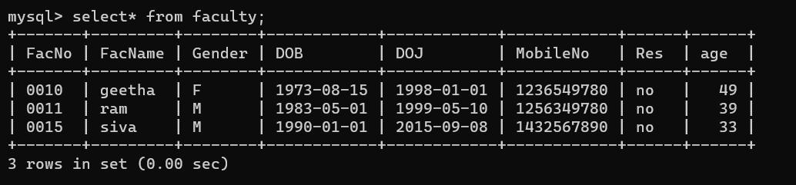

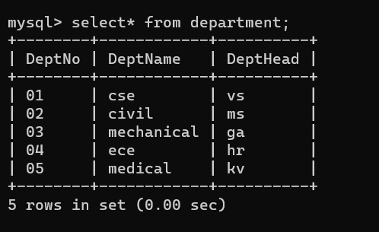



**RESULT**:

Data Manipulation Language (DML) Commands such as INSERT, SELECT are performed in the five tables.